Number Functions Summary

Function | What It Does | Simple Example | Result
ABS(number) | Absolute value -Makes any number positive (removes the minus sign). | ABS(-150) | 150
CEIL(number) | Rounds the number up to the next whole number. | CEIL(259.99) | 260
FLOOR(number) | Rounds the number down to the next whole number. | FLOOR(259.99) | 259
MOD(number, divisor) | Gives the remainder after dividing one number by another. | MOD(16, 10) | 6
POWER(number, power) | Raises a number to a power (exponent). | POWER(12, 2) | 144
ROUND(number, precision) | Rounds a number normally (up or down). | ROUND(259.99, 0) | 260
TRUNC(number, precision) | Cuts off digits after decimal—no rounding. | TRUNC(259.99, 1) | 259.9

- ABS → Absolute (no negative)
- CEIL → Ceiling (go up)
- FLOOR → Floor (go down)
- MOD → Modulus (remainder)
- POWER → Raise it up
- ROUND → Usual rounding
- TRUNC → Cuts off extra decimals

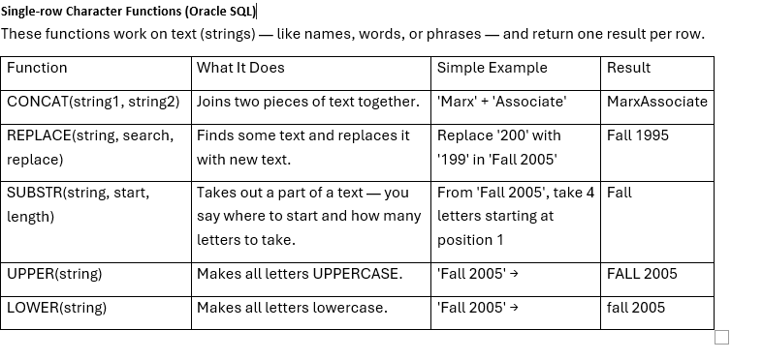

- CONCAT → Connect words
- REPLACE → Replace words
- SUBSTR → Substring (cut part of text)
- UPPER → Make it BIG (capital letters)
- LOWER → Make it small (lowercase letters)

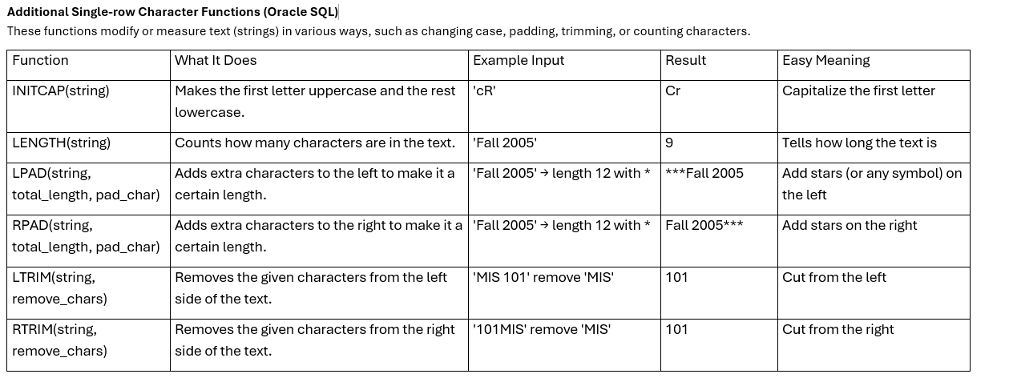

- INITCAP → First letter big (like a name)
- LENGTH → Count letters
- LPAD / RPAD → Add padding (left/right)
- LTRIM / RTRIM → Trim text (left/right)
Aggregate (Group) Functions
Aggregate functions are used to calculate a single value from a group of rows — for example, finding the average, total, or maximum of a column.
They give one answer for many rows (not one answer per row).
Example: find the average salary of all employees.
- You cannot mix normal columns and aggregate results in one SELECT unless you use GROUP BY.
You cannot select a regular (non-aggregate) column together with an aggregate function unless you use GROUP BY.
Aggregate functions (like SUM, COUNT, AVG, MIN, MAX) summarize many rows into one value, but a normal column gives row-by-row data. SQL won’t know which single value to show for that column, so it gives an error — unless we group rows.
Example (will give error)
SELECT department, AVG(salary)
FROM employees;
SQL doesn't know which department value to show for the AVG result, because there are many rows.
Example (using GROUP BY)
SELECT department, AVG(salary)
FROM employees
GROUP BY department;
Now SQL understands:
- Group by department
- Then calculate average salary for each department

- The function usually works on a column name (like salary, marks, etc.).
- You can’t use aggregate functions in the WHERE part — use HAVING instead.

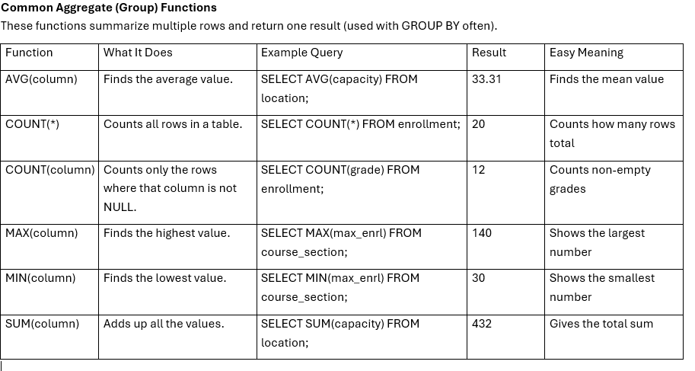

AVG | The average mark in a class
COUNT | How many students there are
MAX | The highest mark
MIN | The lowest mark
SUM | The total marks combined

GROUP BY Clause
The GROUP BY clause groups rows that have the same value in one or more columns — often used with aggregate functions like COUNT, SUM, AVG, MIN, and MAX.
Example:
SELECT department, COUNT(*) AS employee_count
FROM employees
GROUP BY department;
- SQL groups all employees by department.
- Then counts how many employees are in each department.
Output Example:
Department | Employee_Count
HR | 5
IT | 8
Sales | 3

HAVING Clause
The HAVING clause is like a WHERE, but it’s used after GROUP BY to filter groups — not individual rows.
Example:
SELECT department, AVG(salary) AS avg_salary
FROM employees
GROUP BY department
HAVING AVG(salary) > 50000;
- Groups data by department
- Calculates the average salary for each group
- Shows only departments with an average salary over 50,000
Output Example:
Department | Avg_Salary
IT | 65000
Finance | 72000

